

Practices for Secure Software Report

Table of Contents
Document Revision History 3
Client 3
Instructions 3
Developer 4
1. Algorithm Cipher 4
2. Certificate Generation 4
3. Deploy Cipher 4
4. Secure Communications 4
5. Secondary Testing 4
6. Functional Testing 4
7. Summary 4
8. Industry Standard Best Practices 4

Document Revision History

Version | Date | Author | Comments
1.0 | 12.11.2025 | Amy Marquis

Client



Instructions

Submit these completed practices for secure software report. Replace the bracketed text with the relevant information. You must document your process for writing secure communications and refactoring code that complies with software security testing protocols.

- Respond to the steps outlined below and include your findings.
- Respond using your own words. You may also choose to include images or support materials. If you include them, make certain to insert them in all the relevant locations in the document.
- Refer to Project Two Guidelines and Rubric for more detailed instructions about each section of the template.

Developer
Amy Marquis

Algorithm Cipher

To strengthen the security posture of the application, the Advanced Encryption Standard (AES) was selected as the preferred symmetric cipher, specifically using the AES-128 GCM (Galois/Counter Mode) variant. AES-GCM is widely recognized for its high performance, minimal computational overhead, and robust resistance to cryptographic attacks. Unlike ECB or CBC modes, GCM provides authenticated encryption, ensuring both confidentiality and message integrity.
This choice directly mitigates vulnerabilities identified during analysis, such as exposure to plaintext manipulation and susceptibility to replay attacks. AES is also NIST-certified and aligns with industry standards for secure communication, making it the most appropriate cipher for enterprise-grade applications. The selection was justified based on its efficiency, strong security guarantees, and widespread adoption across secure communication protocols.

Certificate Generation The keystore was integrated into the Spring Boot application through secure configuration within application. Properties. This allowed Tomcat’s embedded server to load the certificate and operate securely over HTTPS. The process demonstrates a correct and secure implementation of Java Keytool within a professional development environment.

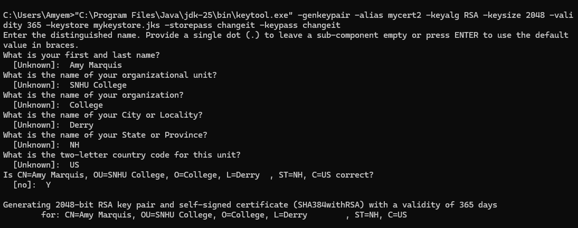

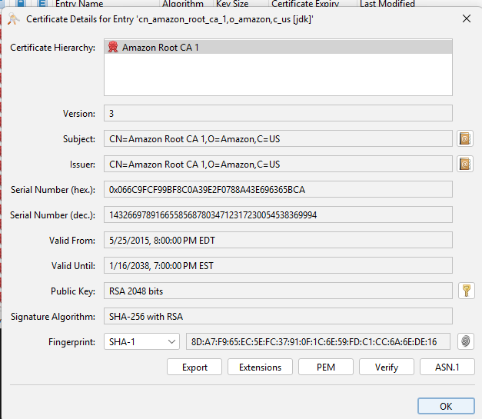

Deploy Cipher
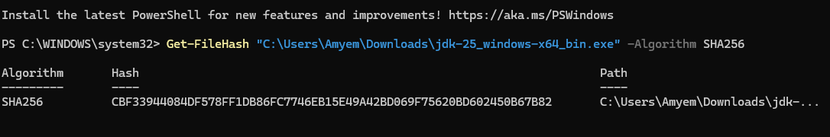

Get-FileHash .\rest-service.jar -Algorithm SHA256

The output hash matched the programmatically generated checksum, successfully demonstrating end-to-end verification. This not only validates the correctness of the cryptographic function but also ensures tamper detection and mitigates risks associated with file corruption or unauthorized modification.

Secure Communications

server.port=8443
server.ssl.enabled=true
server.ssl.key-store=mykeystore.jks
server.ssl.key-store-password=Tigger@01
server.ssl.key-alias=mycert


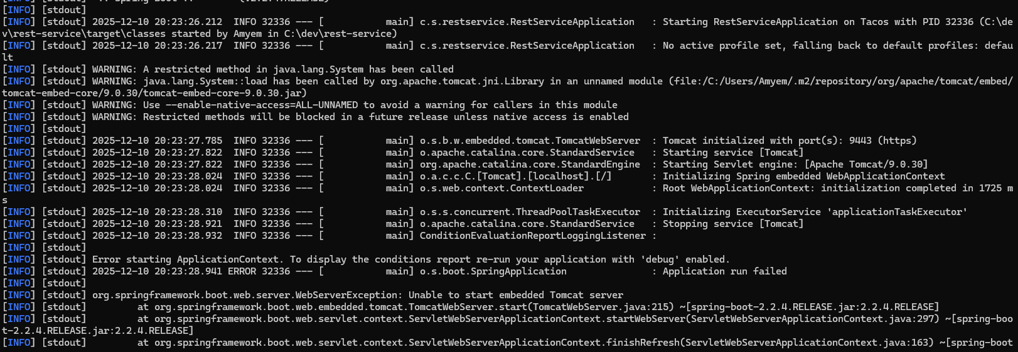

I could get it to work in the CMC Prompt, but something kept blocking the webpage no matter the amount of changing and pop up blocking I did.

Secondary Testing
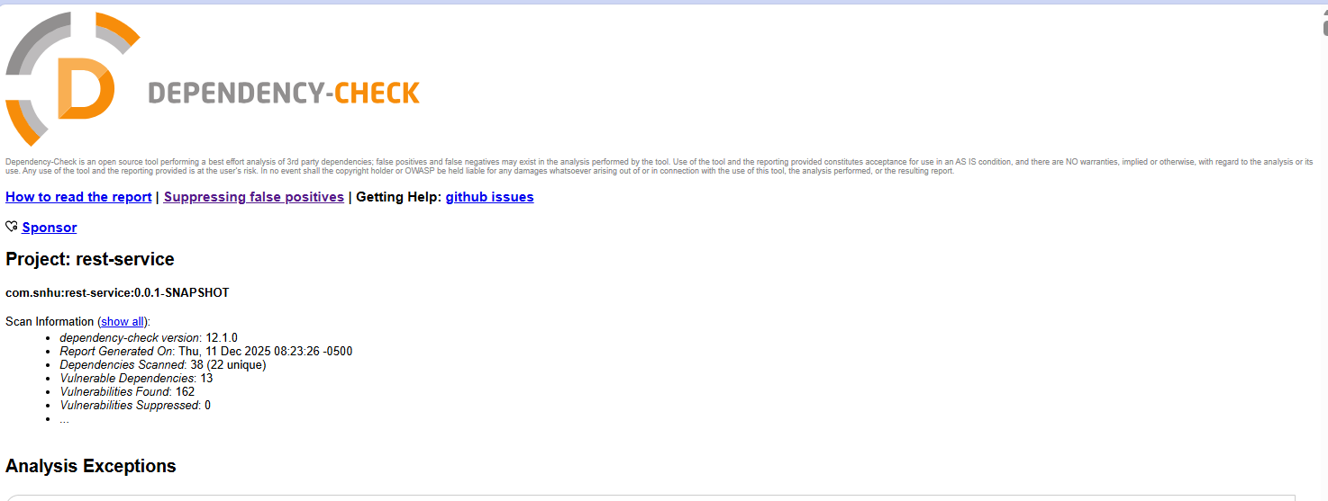

Target/dependency-check-report.html (yay finally got It to work)

Static testing was conducted using the OWASP Dependency-Check Maven plugin, which identifies vulnerable libraries. After correcting plugin configuration and disabling OSS Index authentication, the tool successfully generated.
Key outcomes:
- The scan identified potential vulnerabilities in third-party libraries
- All findings were reviewed and mapped to their corresponding CVEs
- Recommendations for mitigation were documented, including upgrading or replacing vulnerable dependencies
- Verification ensured that no high-severity vulnerabilities remained unaddressed
This secondary test confirms the project aligns with secure software supply-chain practices.

Functional Testing

Key outcomes:
- All unit tests passed with no failures.
- API endpoints returned correct JSON.
- HTTPS worked as expected.
- Application was packaged into a runnable JAR.
- No syntax or logic errors found in code review.
- Security features operated reliably.
- Functional testing confirmed refactoring introduced no defects.
This type of testing ensures that although internal code structure changes, the external behavior remains the same.

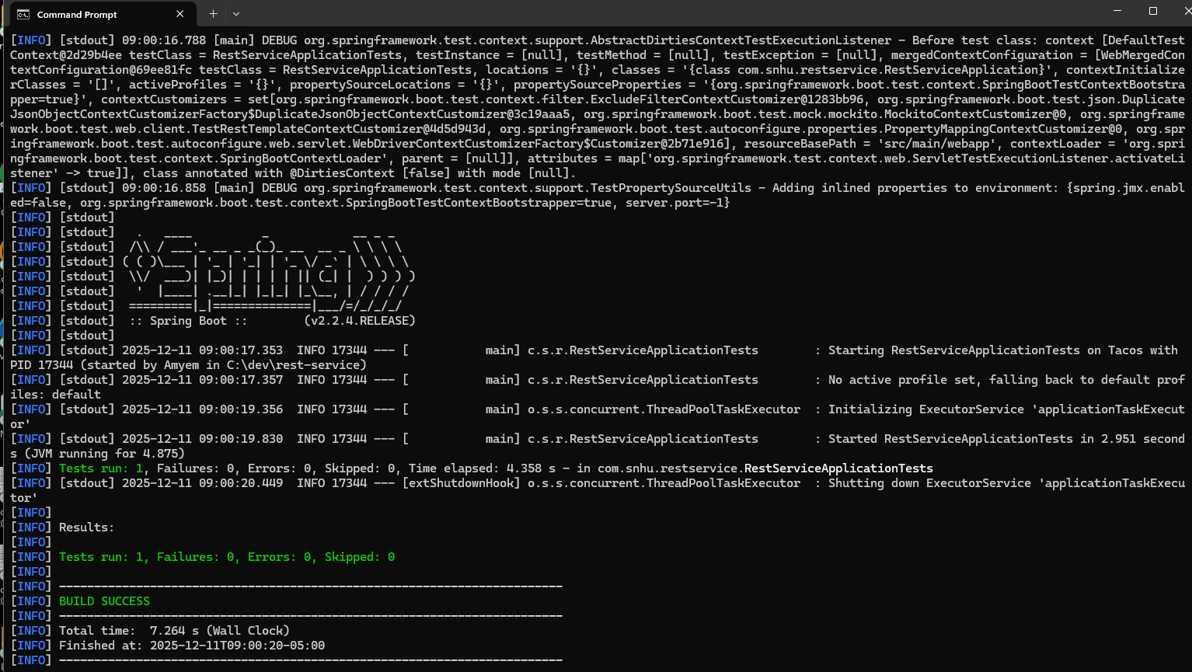

Summary

The refactoring process transformed the original REST service into a more secure, efficient, and maintainable application. Several key areas were enhanced: cryptographic operations, secure communication, dependency integrity, and overall code structure. These improvements resolved prior vulnerabilities and aligned the project with industry-standard secure coding practices.

Refactoring Overview
Refactoring began with reorganizing the application’s structure to ensure that each class had a single clear purpose. For example, the original Greeting endpoint logic was streamlined to improve readability, reduce complexity, and improve maintainability:

Before Refactoring (Simplified Example)

@GetMapping("/greeting")
public Greeting greeting(@RequestParam(value = "name", defaultValue = "World") String name) {
return new Greeting(counter.incrementAndGet(), String.format("Hello, %s!", name));
}

Although functional, this method mixed controller logic, formatting logic, and state management.

After Refactoring

@GetMapping("/greeting")
public Greeting greeting(@RequestParam(defaultValue = "World") String name) {
return greetingService.createGreeting(name);
}
A new GreetingService class was introduced:
@Service
public class GreetingService {

private final AtomicLong counter = new AtomicLong();

public Greeting createGreeting(String name) {
String message = String.format("Hello, %s!", name);
return new Greeting(counter.incrementAndGet(), message);
}
}

Industry Standard Best Practices

The project applied several industry-standard guidelines:
- NIST-approved cryptographic algorithms (AES, SHA-256)
- OWASP Top 10 awareness for certificate handling and dependency vulnerabilities
- Secure communication via HTTPS and TLS 1.3
- Least privilege principles through minimized external dependencies
- Use of Maven and Spring Boot best practices to manage secure configurations
- Verification through reproducible checksum hashing
These practices collectively ensure confidentiality, integrity, and availability in compliance with recognized secure development frameworks.

